Christopher Straight
300363269
ENGR 101

1

1. 1 + 2 + 8 = 11

2. 13
8 + 4 + 1 = 13
1101

3. 5

4. 10

2
5. compiling code converts it into a form the computer can run

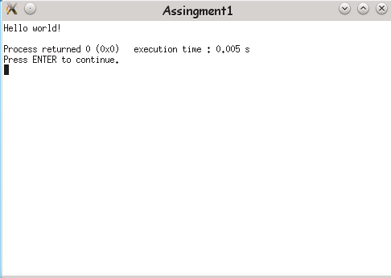
6.

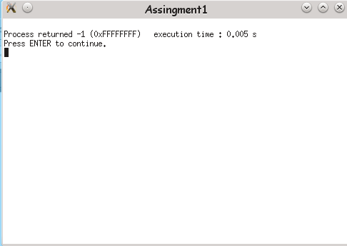
7.

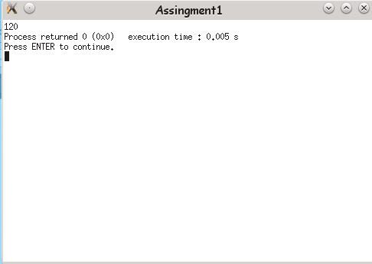

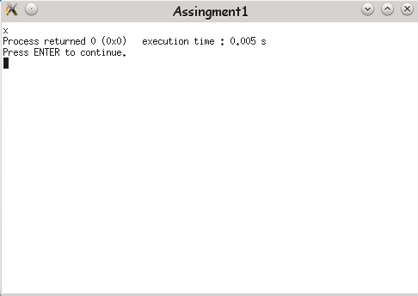
completion 1.

%c tells the computer that number
is a character
so it looks for the character represented by 120 which is x

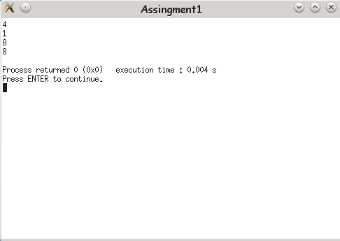
8.

Integer | 4
Character | 1
Double | 8
Long | 8

3

9.
1 | 1 | 0 | 0
1 | 0 | 1 | 0
3 | 2 | 1 | 0

1 | 1 | 0 | 0
1 | 0 | 1 | 0
-1 | 0 | 1 | 0

challenge 2.

10.
13 = 0000 1101
60 = 0011 1100

11.
0000 1101 AND
0011 1100
= 0000 1100 = 12

12.
0000 1101 OR
0011 1100
= 0011 1101 = 61
13.
0000 1101 XOR
0011 1100
= 0011 0001 = 49

completion 2.

